Piezoelectric Micromachined Ultrasonic Transducers for Consumer Devices
David Horsley
Professor, Mechanical and Aerospace Engineering, University of California, Davis

Micromachined ultrasonic transducers (MUTs) are best known for their use in medical imaging, a field where imaging performance dominates over features such as transducer size, weight, power consumption and cost. In comparison, these features are the main drivers for the success of the MEMS sensors used in consumer electronics and automotive applications, such as pressure sensors, accelerometers, gyroscopes, and microphones. These MEMS sensors replaced their conventional counterparts in existing applications and, more important, enabled novel and unexpected applications (such as smart phones, toys, fitness trackers, etc.) where low cost, small size, light weight, and ultra-low power consumption are critical.
In this talk, I will describe MEMS ultrasonic sensors based on piezoelectric MUTs (PMUTs) intended for consumer electronics applications such as range-finding and fingerprint sensing. A common characteristic of these applications is that they require manufacturing at high volume with relatively low cost. We have developed air-coupled ultrasonic sensors based on PMUTs that operate at 15 microwatts. Relative to optical sensors, these ultrasonic sensors have the advantage of very low power consumption and long range (> 1 m). In related research, we demonstrated a 500 DPI ultrasonic fingerprint sensor that has similar resolution to Apple’s TouchID sensor but the added advantages that it is capable of imaging wet or oily fingers and can image the dermis beneath the surface of the finger.
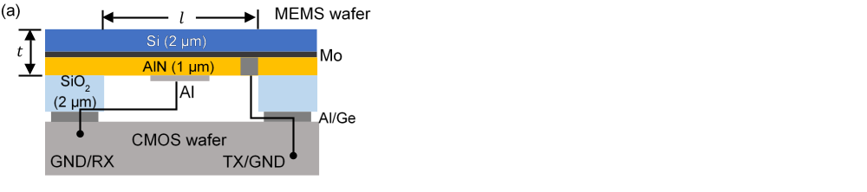 | 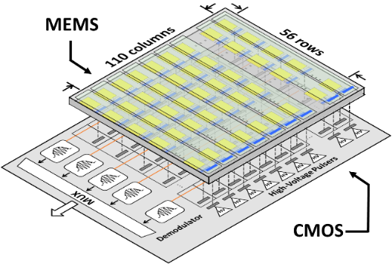 | 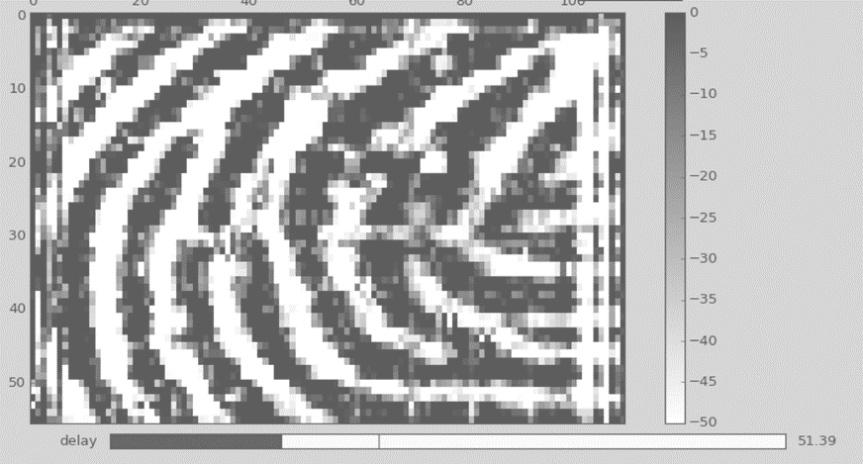  3.36 mm  4.64 mm
- PMUT cross-section | - Ultrasonic fingerprint sensor | - Ultrasonic fingerprint image

Biography

David A. Horsley received his PhD in Mechanical Engineering from the University of California, Berkeley, in 1998. He is co-founder and CTO of Chirp Microsystems Inc. (a TDK Group Company), a manufacturer of ultrasonic sensors using MEMS technology. Dr. Horsley is also a Professor of Mechanical and Aerospace Engineering at the University of California, Davis, and Adjunct Professor of Mechanical Engineering at the University of California, Berkeley. Since 2004, he has been Co-Director of the Berkeley Sensor and Actuator Center (BSAC), the National Science Foundation’s Industrial/University Collaborative Research Center (I/UCRC) focused on MEMS research. Dr. Horsley was Co-Chair of the 2016 IEEE Sensors Conference, Co-Chair of the 2017 Transducers Research Foundation Napa Microsystems Workshop, and he is the Co-Chair of the 2020 IEEE MEMS Conference. Dr. Horsley is a recipient of the National Science Foundation’s CAREER Award, the Outstanding Junior Faculty Award at UC Davis, the 2016 NSF I/UCRC Association’s Schwarzkopf Award for Technological Innovation, the 2018 East Bay Innovation Award, and has authored or co-authored over 150 scientific papers and holds over 20 patents.

