

Vortex-ring collisions upon solid surfaces
Dr. New Tze How, Daniel
Associate Professor, Mechanical and Aerospace Engineering
Nanyang Technological University

Date: 22 November 2018 (Thursday)
Time: 3:30pm – 5:00pm
Venue: 工程五館B1國際會議廳 Engineering Building 5 B1 International Conference Hall

Abstract
A vortex-ring is one of the most fundamental vertical structures that one can encounter in the study of fluid dynamics. Despite their simplicity however, their behavior can very often inform us upon more complex flow scenarios, such as vortex-structure interactions, vortex-boundary layer interactions, vortex impingement and others. Furthermore, the robustness of numerical schemes used in numerical simulations can quite often be validated by the modelling of vortex-ring behavior, due to the latter’s robustness. In this seminar, results arising from recent investigations into the flow behavior associated with vortex-ring collisions with solid boundaries will be presented and discussed. In particular, laser-induced fluorescence visualizations and time-resolved particle-image velocimetry measurements will be used to provide insights into the evolutions of the various vertical structures resulting from the preceding flow scenarios. At the same time, vortex flow models will be constructed from these experimental results where possible to explain how seemingly simple and canonical vortex-rings can produce surprisingly 3D flow fields.

Speaker Profile
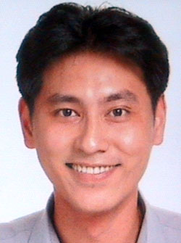
New T.H. graduated from National University of Singapore with a PhD in Mechanical Engineering in 2004. Prior to his current Associate Professor position at the School of MAE, NTU (Nanyang Technological University, Singapore), he has engaged in numerous research projects in TL@NUS as a Research Scientist (aerodynamics and combustion, 2000-2005), University of Texas, Arlington as a visiting post-doc researcher (combustion, 2004-2005) and University of Liverpool as a Lecturer (flow control and combustion, 2005-2010). He has won competitive research grants from EPSRC UK and The Royal Society when he was with University of Liverpool, UK, and collaborated with DSTL, UK Ministry of Defense. Since then, he has been awarded, managed and completed several significant competitive research grants from MINDEF, FSTD, DSO, MOE, MPA and Jurong Port, among others in Singapore. He is also NTU’s primary point-of-contact for a recent research collaboration with Leonardo-Finmeccanica, the world-renowned defense company. His research articles have appeared in Journal of Fluid Mechanics, Physics of Fluids, Experiments in Fluids, AIAA Journal (among others) and his current research interests include vortex-ring and jet vortex dynamics, propulsion and supersonic jets.

